**FULL STACK ASSIGNMENT – 1**

1.* ------- expression

'hello'  ------ value

-87.8    ------ value

- -------------- expression

/       ------------------- expression

+   ---------------------- expression

6  -------------------- value

**2.** String: String can be written in quotes such: "apple", 'apple'

Variable: It is the thing in which we can store data just like a container.

**3.** List: the list is used for storing multiple data items in a single variable.

Integer: integer can store only numerical values.

Float: float can store only floating values such as 233.33, 22.2, etc.

**4.**  Expression is made up of values, containers, and mathematical operators (operands) e.g

     a = 2 + 3     and expressions are used to evaluate the values or represent the result on the screen.

**5.** Expression is made up of values, containers, and mathematical operators (operands) and the statement is just like a command that a python interpreter executes like print.

**6.** Sol: it gives 23 as execution code

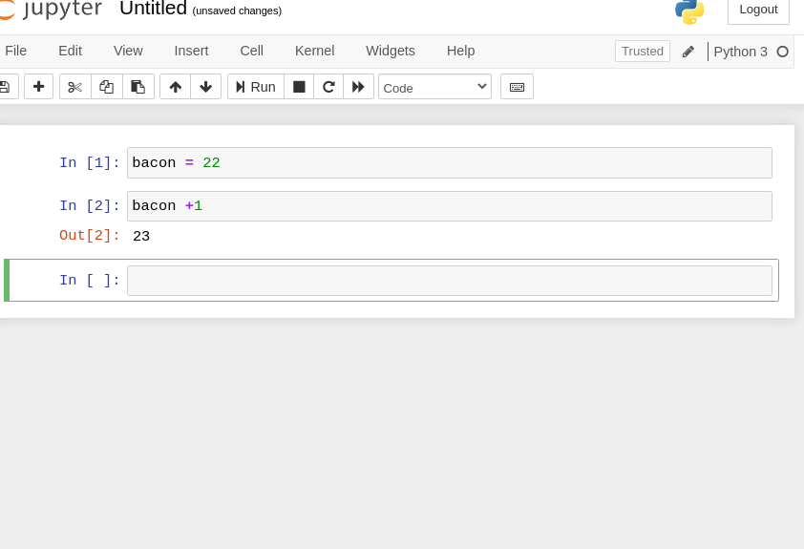

**7.** it will be the same

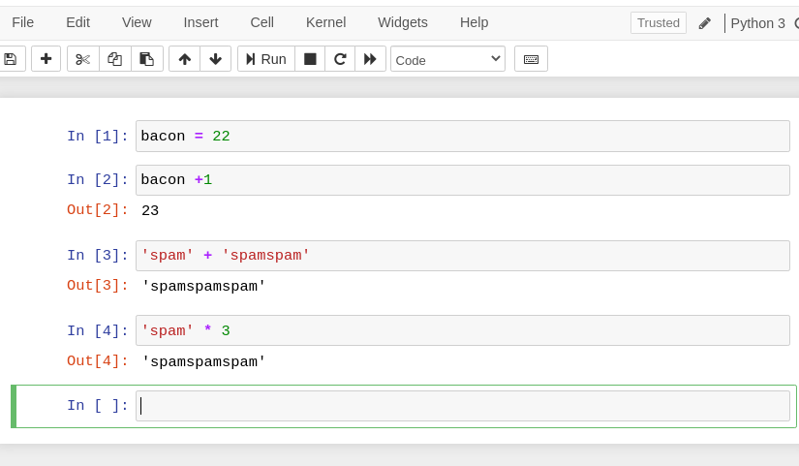

**8.**  Ans: because we can't start giving variable an integer name. if we, we should begin with, a string-like alphabet name then integer. e100 or

eggs100 is valid.

**9.** ans: str(), int(), float()

**10.** 'I have eaten' + 99 + 'burritos'

sol:  because 99 is an integer it cannot be concatenated with strings, if we have to concatenate it we need to do typecasting.